Steven Layne

EECS 351

Sol307

**Project C: Swirly Trees and Missing Bees**

This graphics project utilizes WebGL and HTML5 to create animate shapes in a web browser relative to a ground grid. The user can navigate through a seemingly infinitely expansive spaces using the arrow keys and other key combinations providing 5 degrees of freedom. The user can navigate around multiple objects and there is a light orb, light source, that the user can move around and see how the light reflects off of the phong materials.

Controls:

Arrow Keys(Left, Right, Up, Down): Moves the user in the left right up and down direction respectively.

A Key: Pan left.

D Key: Pan right.

W Key: Pan up.

S Key: Pan down.

Q: Zoom in.

E: Zoom out

Light Orb Controls:

I – Key: Move light source backwards.

K – key: Move light source forwards.

U – Key: Move light source up.

O – key : Move light source down.

J – Key : Move light source left.

L – Key: Move light source right.

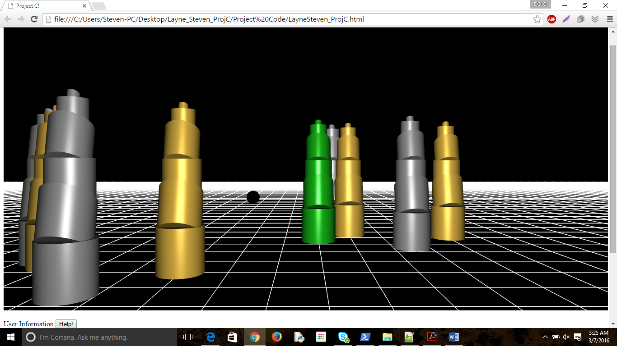

Figure 1: Shows the trees in their space made of Phong Materials. Eye point light source is on in this picture.

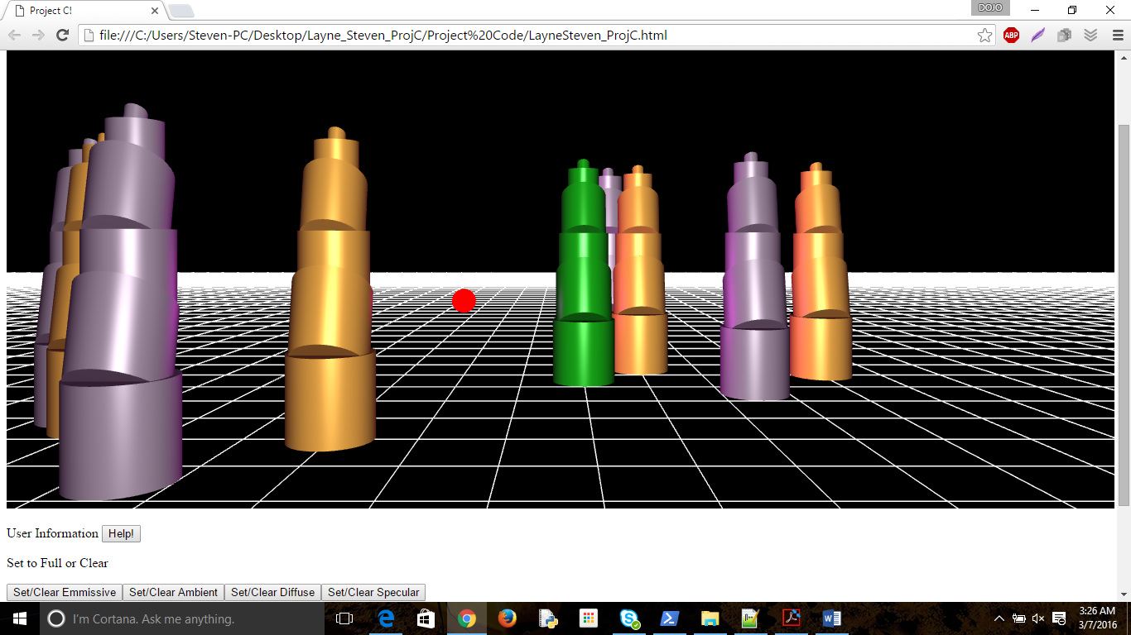

Figure 2: Shows the addition of a light source with RGB(.05,0,0).

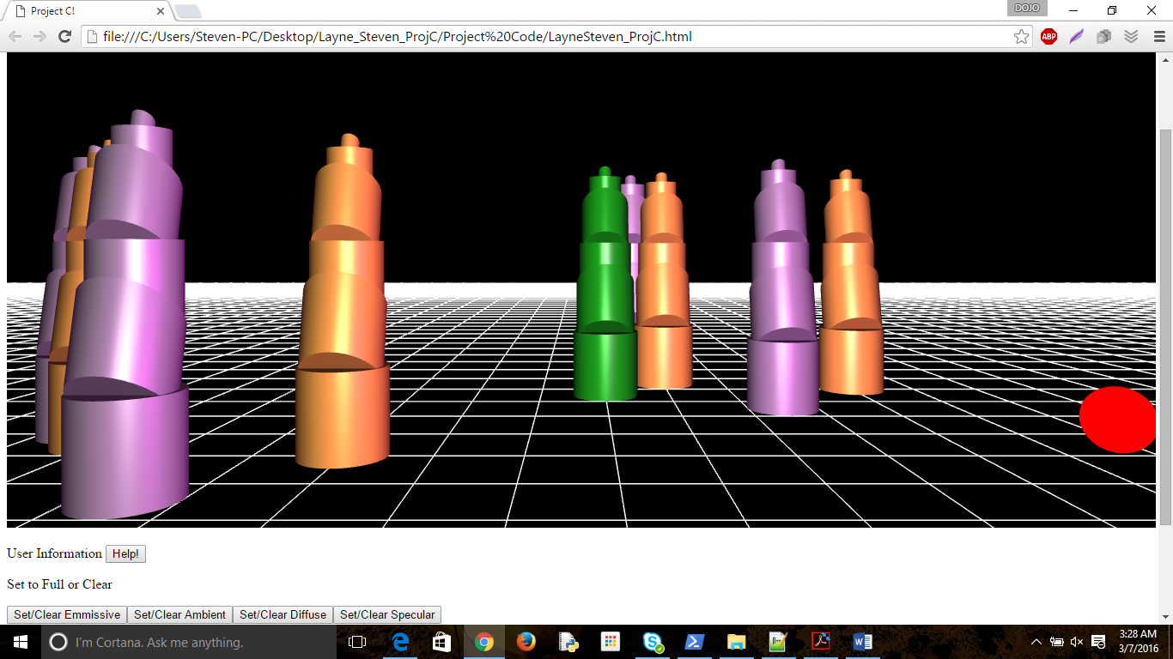

Figure 3: Same light source coloring from a different point of origin for the light source.

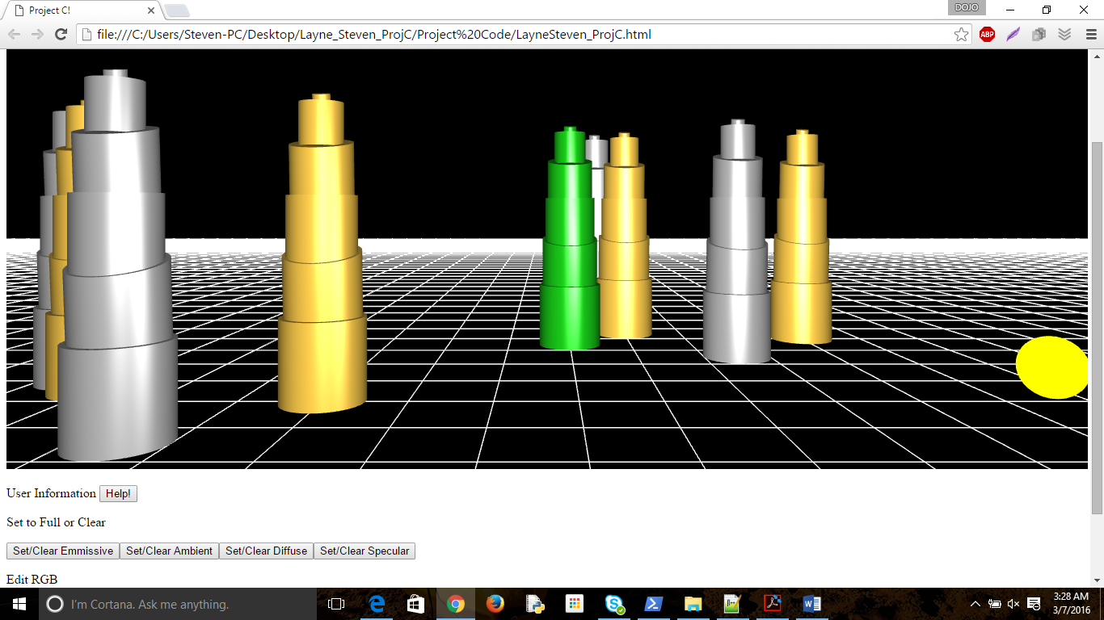

Figure 4: Shows ambient lighting effects.

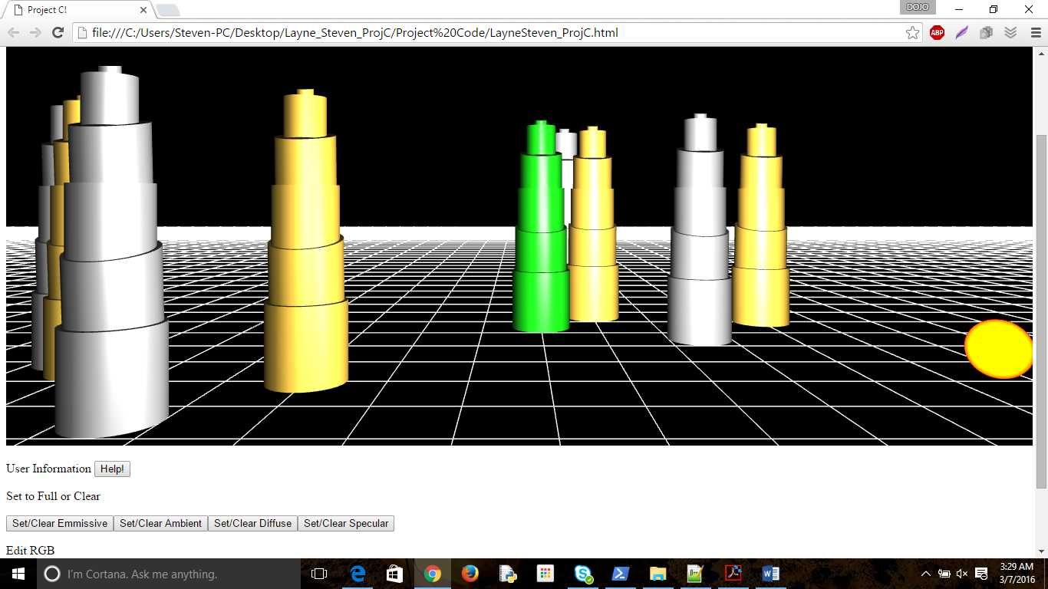

Figure 5: Shows diffuse lighting effects.

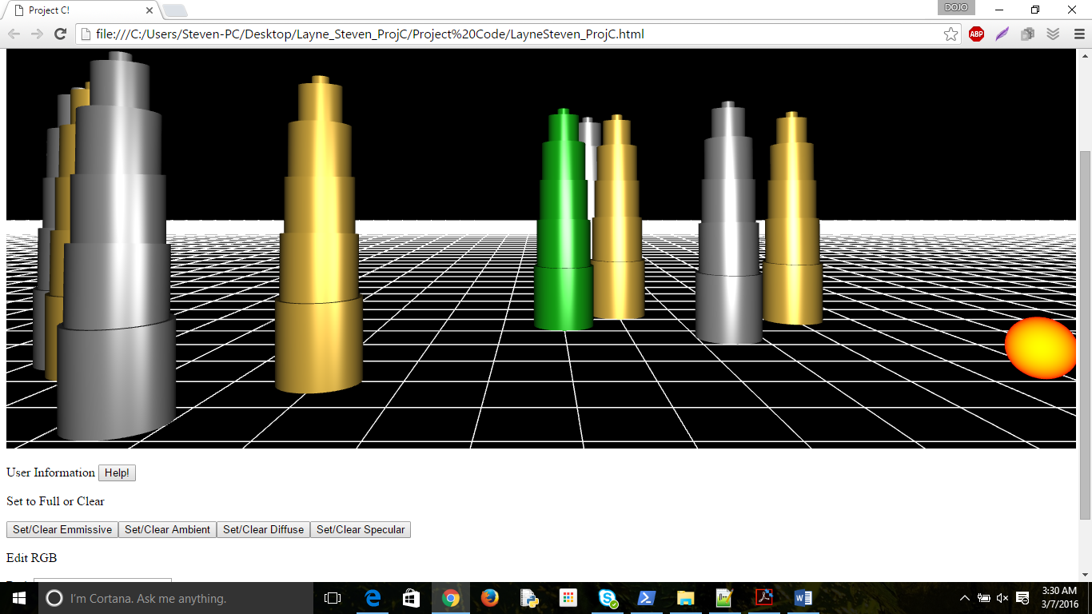

Figure 6: Specular Lighting effects.

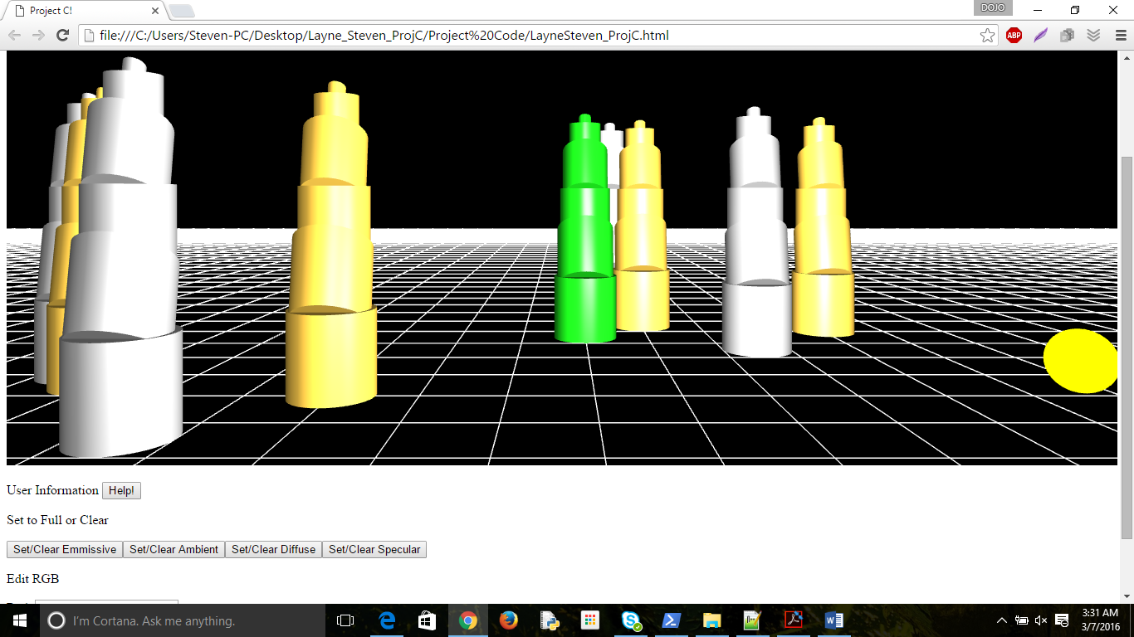

Figure 7: Additive. Specular, Ambient and Diffuse.